AI Course
Chapter 3. Quiz

For students
Date: 19/02/2026
Name: Shashank Naragundmath
USN: 2KE22EC126

ⓒ2022 SAMSUNG. All rights reserved.
Samsung Electronics Corporate Citizenship Office holds the copyright of this document.
This document is a literary property protected by copyright law so reprint and reproduction without permission are prohibited.
To use this document other than the curriculum of Samsung Innovation Campus, you must receive written consent from copyright holder.

Max: 100 Marks, Total: 19 Questions, 1-5 Descriptive Type and 6-19: MCQ Objective Type.

Duration: 1 Hr 30 Min..

- Answer the following questions using Pandas library.
import pandas as pd
import os
Read in the data.
# Go to the directory where the data file is located.
# os.chdir(r'~~') # Please, replace the path with your own.
df = pd.read_csv('data_studentlist.csv', header='infer')
df.head(5)
1) Average height of the male students: 172.41 cm 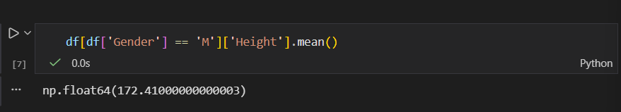 2) Average height of the female students: 166.6428 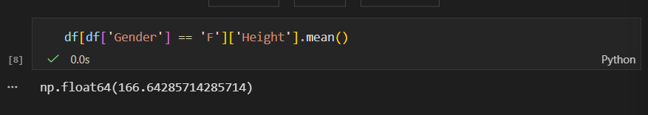3) Average weight of the male students: 68.5 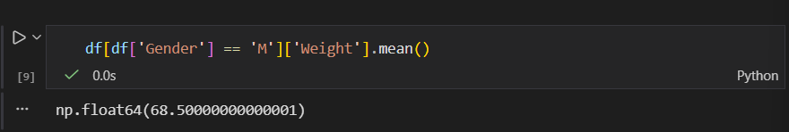4) Average weight of the female students: 50.4428 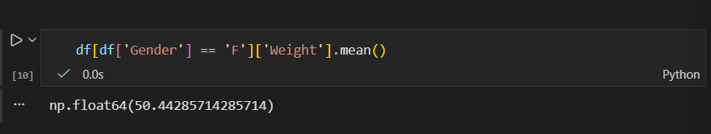5) The tallest height among the male students: 182.1 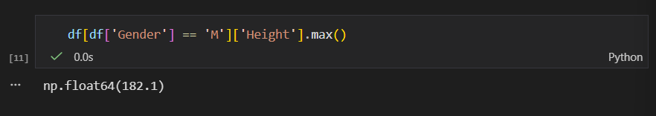
6) The shortest height among the female students: 155.2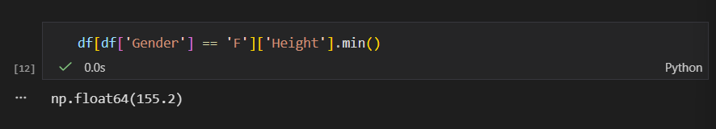 7) The lightest weight among the male students of height taller than 175cm: 61.3 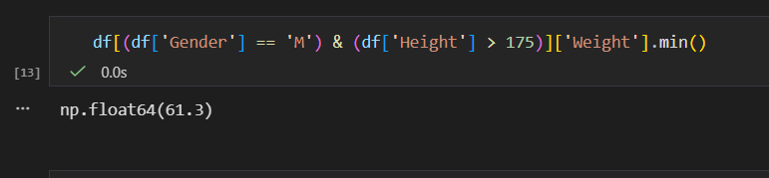8) The heaviest weight among the female students of height shorter than 160cm: 45.3 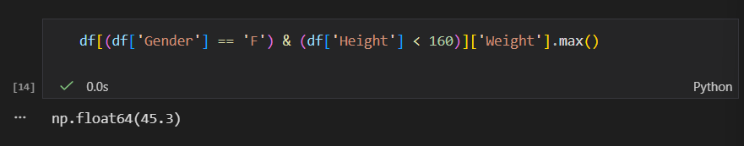9) The average grade of students without absence ('N'): 2.0769 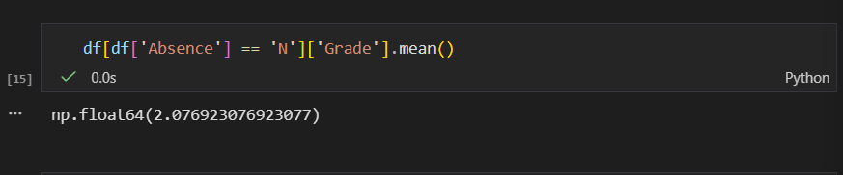 10) The average grade of students with absence ('Y'): 3.0 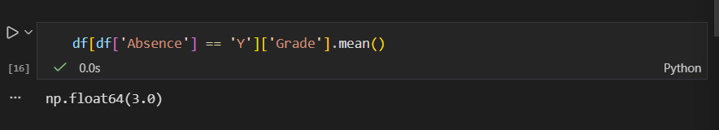 11) Average height of the students with blood type 'A' or 'AB': 172.6428 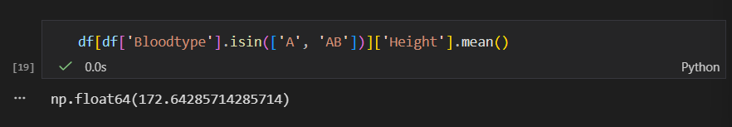
12) Average height of the male students with blood type 'A' or 'AB': 173.375 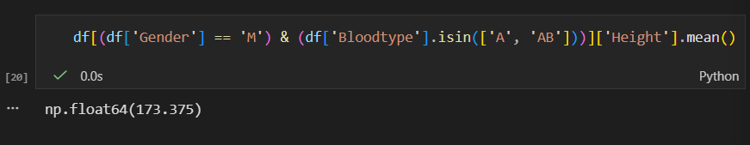 13) Average age of the students with absence ('Y') whose grade is equal or larger than 3: 23.6667 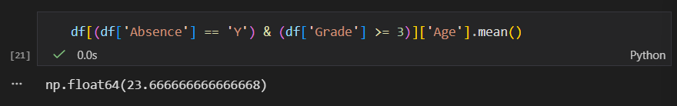

- Answer the following questions using Pandas library.
import pandas as pd
import numpy as np
import os

Read in the data.
# Go to the directory where the data file is located.
# os.chdir(r'~~') # Please, replace the path with your own.
df = pd.read_csv('data_census.csv', header='infer')
df.shape
df.head(10)

- Total population of ProvinceCode equal to 115 and 116: [ 2,068,444 602,939 260,326 342,613 112,282 104,738 295,751 168,415 124,542 40,052 164,121 54,990 71,388 57,198 32,191 92,766 84,158 62,913 615,250 454,673 160,577 ]
- Average population of the cities where there are more males: 419221.20769 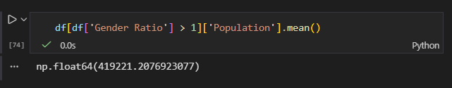
- Places with more males (GenderRatio >1) and less than 2 persons per household: 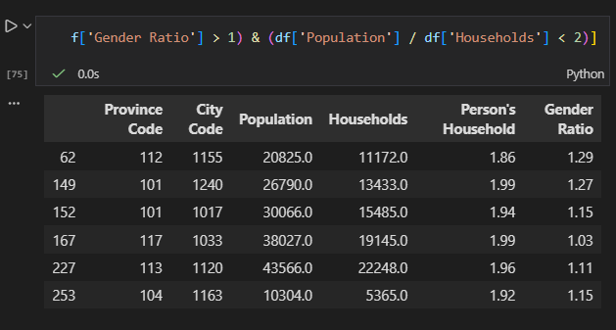
- Sort the DataFrame in ascending order of the 'Households'. Show the top 10 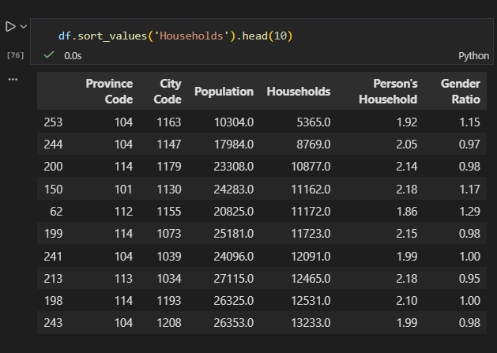

- Answer the following questions.
import pandas as pd
import numpy as np
import os

Read in the data.
# Go to the directory where the data file is located.
# os.chdir(r'~~') # Please, replace the path with your own.
df = pd.read_csv('data_sales.csv', header='infer')
df.shape
df.head(5)

- Append a new variable 𝐴𝑚𝑜𝑢𝑛𝑡=𝑈𝑛𝑖𝑡𝑃𝑟𝑖𝑐×𝑈𝑛𝑖𝑡𝑠Amount=UnitPric×Units. 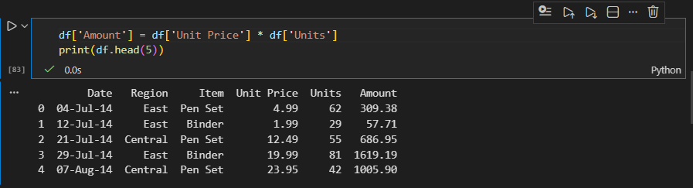
- Average unit price for each region. Use the groupby() method. 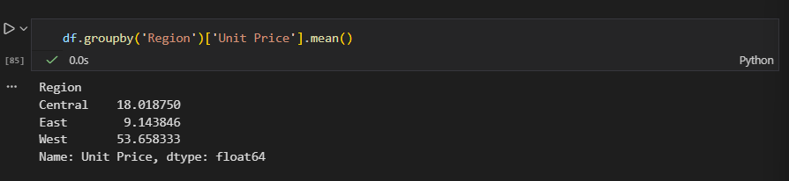
- Average unit price for each region. Use the pivot_table() method. 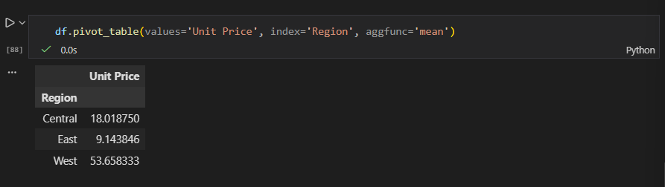
- Average unit price and units for each region in one code sentence. Use the groupby() method. 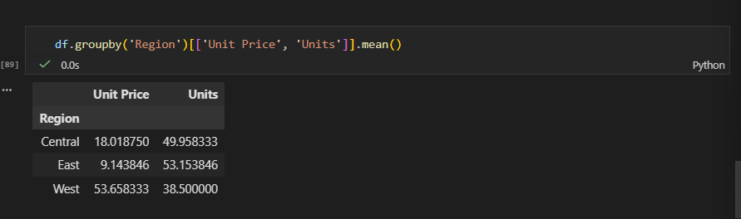
- Average unit price and units for each region in one code sentence. Use the pivot_table() method. 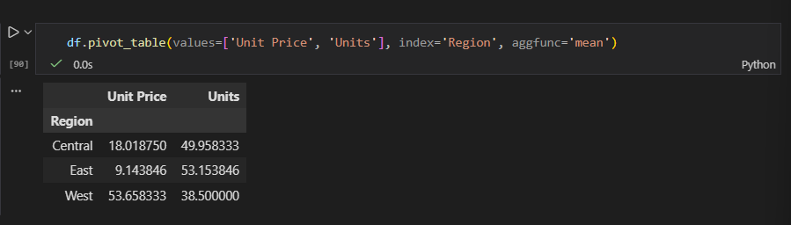
- Total units for each region and item type in one code sentence. Use the pivot_table() method. Fill the missing values with 0. 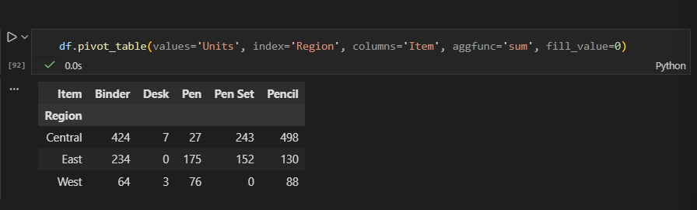
- Total sales amount for each region and item type in one code sentence. Use the pivot_table() method. Fill the missing values with 0. 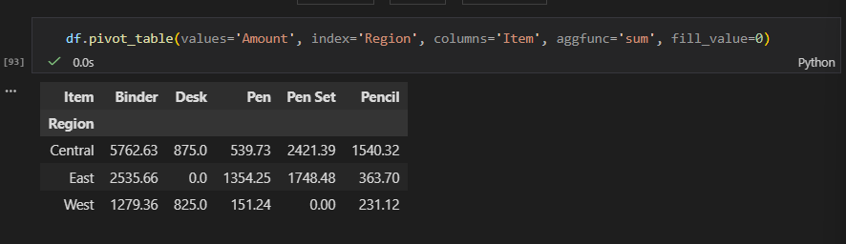
- Answer the following questions.
import pandas as pd
import numpy as np
import os
import matplotlib.pyplot as plt
%matplotlib inline

Read in the data.
# Go to the directory where the data file is located.
# os.chdir(r'~~') # Please, replace the path with your own.
df = pd.read_csv('data_coffeeshop.csv', header='infer',na_values=[' '])
df.shape
df.head(5)

1) Make a frequency table of 'yearOfStart' and visualize by year.
- Sort by the year.
- Draw a line plot from 1997 to 2014. <= Hint: plt.xlim()
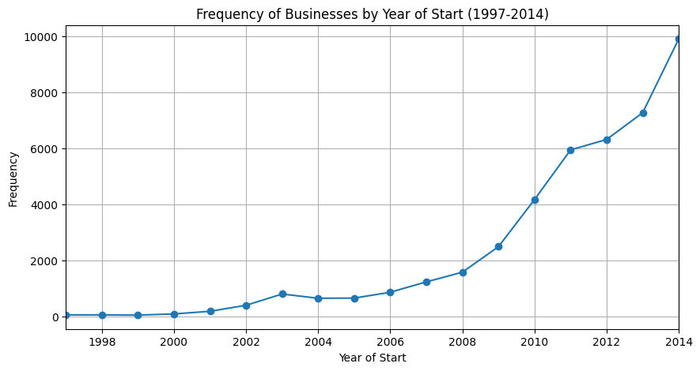

2) Split the data by the current state of business ('In' or 'Out' of business). Then, visualize the yearly trend of the 'yearOfStart' frequencies. 4M
- Sort by the year.
- Draw two overlapping line plots from 1997 to 2014.
- Use the 'figure' object.
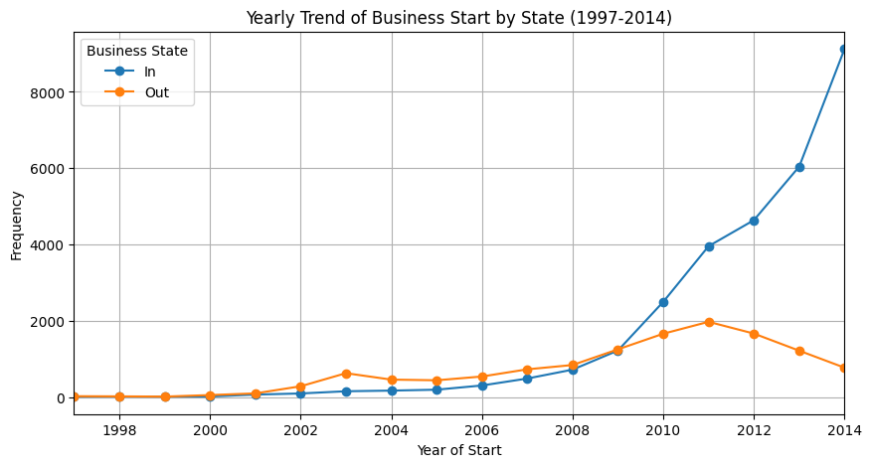
3) From the results of 1) and 2), how can you describe the trend in general? 5M
From the above plots:
- The frequency of business starts generally fluctuates between 1997 and 2014, with some years showing peaks and others dips.
- When split by 'currentState', both 'In' and 'Out' of business follow similar trends, but the number of businesses that are 'Out' may increase in certain years, indicating possible business closures after initial peaks.
- Overall, the trend may suggest periods of increased entrepreneurship followed by stabilization or decline, possibly due to economic or market factors.

5. What is a correct syntax to create a NumPy array? 1M
- np.createArray([1, 2, 3, 4, 5])
- np.array([1, 2, 3, 4, 5])
- np.object([1, 2, 3, 4, 5])

6. Which of the following arrays is a two dimensional (2-D) array? 1M
- 42
- ([1, 2, 3], [4, 5, 6])
- [1, 2, 3, 4, 5]

7. What is a correct syntax to check the number of dimensions in an array? 1M
- np.dim()
- np.ndim()
- np.ndim
- np.dim

8. What is a correct syntax to print the first item of an array? 1M
- print(myArr[0])
- print(myArr,1)
- print(myArr[1])

9. What is a correct syntax to print the number 8 from the array below: 1M
arr = np.array([[1,2,3,4,5], [6,7,8,9,10]])

- print(arr[3, 0])
- print(arr[7, 2])
- print(arr[1, 2])
10. What is a correct syntax to print the numbers [3, 4, 5] from the array below: 1M
arr = np.array([1,2,3,4,5,6,7])

- print(arr[2:4])
- print(arr[2:5])
- print(arr[2:6])
- print(arr[3:6])

11. What is a correct method to join two or more arrays? 1M
- array_join()
- concatenate()
- join()

12. What is a correct syntax to return the index of all items that has the value 4 from the array below: 1M
arr = np.array([1,4,3,4,5,4,4])

- arr.search(4)
- arr.where()
- np.where(arr==4)

13. When using the NumPy random module, how can you return a random number from 0 to 100? 1M
- random.rand(100)
- random.rand()
- random.randint(100)

14. When using the NumPy random module, how can you return a Normal Data Distribution with 1000 numbers, concentrated around the number 50, with a standard deviation of 0.2? 1M
- random.normal(size=1000, loc=50, scale=0.2)
- random.normal(size=1000, mean=50, deviation=0.2)
- random.normal(size=1000, normal=50, s=0.1)

15. What is a correct syntax to mathematically add the numbers of arr1 to the numbers of arr2? 1M
- np.add(arr1, arr2)
- np.append(arr1, arr2)
- sum(arr1, arr2)

16. What is a correct syntax to subtract the numbers from arr1 with the numbers from arr2? 1M
- np.min(arr1, arr2)
- np.minus(arr1, arr2)
- np.sub(arr1, arr2)
- np.substract(arr1, arr2)
17. What is a correct method to round decimals in NumPy? 1M
- np.fix()
- np.trunc()
- All the other 3 are rounding methods in NumPy
- np.around()

18. What would be the answer of this cumulative summation in NumPy? 1M
arr = np.array([1,2,3])
print(np.cumsum(arr))

- [3, 6, 9]
- [6]
- [9]
- [1 3 6]

19. What is a correct syntax to create a Pandas Series from a Python list? 1M
- pd.Series(mylist)
- pd.createSeries(mylist)
- pd.getSeries(mylist)

